**MACHINE LEARNING BASED SPAM COMMENTS DETECTION ON YOUTUBE**

**ABSTRACT**

The rise of spam comments on platforms like YouTube has become a significant concern, as they not only hinder genuine user engagement but also pose serious risks to users' safety and privacy. Machine Learning (ML) offers a powerful solution to combat spam comments by automating the process of detecting and preventing them. With the ability to analyze vast amounts of data and patterns, ML algorithms can effectively distinguish between legitimate comments and those that are spam. One of the commonly employed approaches in ML for spam comment detection is the Naive Bayes classification algorithm. Naive Bayes is a probabilistic algorithm that calculates the likelihood of a comment being spam based on its characteristics and the occurrence of specific keywords or phrases that are typical of spam content. By training the algorithm on a labeled dataset of spam and non-spam comments, it can learn to recognize patterns and generalize its understanding to new, unseen comments. Achieving a detection accuracy of 92.78% is indeed promising, but researchers and developers continue to explore other ML techniques and combinations to further improve the accuracy and robustness of spam comment detection systems. Ensemble methods, deep learning, and natural language processing (NLP) techniques are among the advanced ML approaches gaining attention in this domain. One crucial aspect of an effective spam detection system is its adaptability and responsiveness to emerging spam tactics.

**Keywords**: ML evaluation, ML techniques , Naïve bayes , decision tree , MLP classifier etc.,.

**PROBLEM STATEMENT**

The problem statement of Machine Learning-based spam comments detection on YouTube is to develop a predictive model that can classify YouTube comments as either spam or not spam. The model will analyze the content and characteristics of comments, utilizing ML algorithms, to automatically identify and filter out spam comments. The objective is to create a robust and efficient system that enhances user experience, safeguards user privacy, and reduces the volume of spam comments on the platform.

**WHY IS THE PARTICULAR TOPIC CHOSEN?**

The particular topic of Machine Learning-based spam comments detection on YouTube is chosen due to the significant and growing issue of spam comments on the platform. As YouTube serves as a widely used platform for entertainment, learning, and user interaction, the rise of spam comments poses risks to user safety and privacy. By employing ML algorithms to detect and prevent spam, this research aims to create a safer and more enjoyable user experience while mitigating potential scams and harmful content.

**SCOPE**

The scope of Machine Learning-based spam comments detection on YouTube is vast, as it addresses a pressing issue affecting user engagement and safety on the platform. By implementing this system, YouTube can significantly reduce the presence of harmful, irrelevant, or offensive content in the comment section. Furthermore, the scope extends beyond YouTube, as similar ML-based spam detection systems can be adapted and applied to other social media platforms or online communities to create a safer and more enjoyable user experience.

**OBJECTIVE OF THE PROJECT**

The objective of the Machine Learning-based spam comments detection project on YouTube is to develop an accurate and efficient system that can automatically identify and filter out spam comments from the comment section. By doing so, the project aims to enhance user safety, privacy, and engagement on the platform. Additionally, the project intends to contribute to creating a positive and constructive online community by preventing scams, irrelevant content, and offensive messages from being displayed to users.

**EXISTING METHOD**

In the existing methods for spam comment detection on YouTube, researchers have employed the support vector machine , k-neighbours, neural network algorithm as one of the key machine learning techniques. These are probabilistic algorithms that calculates the likelihood of a comment being spam based on its characteristics and occurrence of specific keywords or phrases typical of spam content. The algorithm's simplicity and efficiency make it a popular choice for classifying comments and distinguishing between spam and non-spam with satisfactory accuracy.

**DISADVANTAGES**

1. Independence assumption: Naive Bayes assumes that all features (words or phrases) in a comment are independent of each other, which is often not true in natural language. This can lead to inaccuracies in the classification, especially when comments contain complex or context-dependent patterns.

2. Handling out-of-vocabulary words: Naive Bayes relies on the occurrence of specific words or phrases in the training data. If a comment contains words that were not seen during training (out-of-vocabulary words), the algorithm may struggle to accurately classify the comment, leading to false positives or false negatives.

3. Sensitivity to feature relevance: The performance of Naive Bayes heavily depends on the choice and quality of features used for classification. Selecting relevant features is critical, and if important features are overlooked or less informative features are included, it can impact the overall accuracy of the spam detection system.

**PROPOSED SYSTEM**

The proposed system aims to enhance the accuracy of spam comment detection on YouTube by implementing a combination of advanced ML algorithms, including Navie bayes ,Decision Tree, MLP Classifier, and AdaBoost. By leveraging the strengths of these algorithms, the system seeks to overcome the limitations of the Naive Bayes approach and achieve better performance in distinguishing between spam and non-spam comments. Through this improved accuracy, the proposed system aims to provide a safer and more reliable environment for YouTube users, mitigating the risks of scams, offensive content, and privacy breaches.

**PROJECT FLOW**

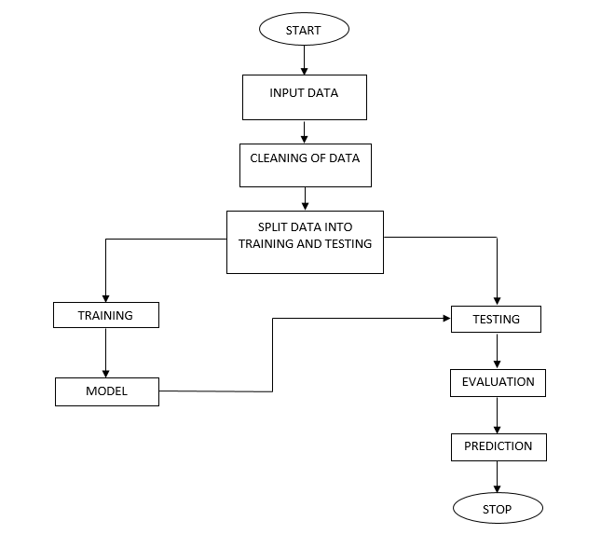

**ADVANTAGES**

1. Enhanced Accuracy: By leveraging multiple advanced ML algorithms, the system can effectively capture various patterns and features in comments, leading to higher accuracy in distinguishing between spam and non-spam comments. This improvement over the traditional Naive Bayes approach ensures a more reliable spam detection system.

2. Robustness and Generalization: Each algorithm brings its unique strengths to the ensemble, increasing the system's robustness and ability to generalize well to new and unseen data. The combined approach reduces the risk of over fitting and enables the system to handle diverse types of spam comments effectively.

3. Effective Feature Selection: Different algorithms excel at different types of feature interactions. The proposed combination allows for more effective feature selection, ensuring that relevant features are considered while filtering out noise and irrelevant information from comments, thereby enhancing the system's overall performance.

**SOFTWARE FRONT END REQUIREMENTS**

# **H/W CONFIGURATION:**

# Processor - I3/Intel Processor

Hard Disk - 160GB

Key Board - Standard Windows Keyboard

Mouse - Two or Three Button Mouse

Monitor - SVGA

RAM - 8GB

**S/W CONFIGURATION:**

* Operating System : Windows 7/8/10
* Server side Script : HTML, CSS, Bootstrap & JS
* Programming Language : Python
* Libraries : Flask, Pandas, Mysql.connector, Numpy
* IDE/Workbench : PyCharm
* Technology : Python 3.6+
* Server Deployment : Xampp Server

**MODULES/IMPLEMENTATION**

The proposed project consists of a user-friendly UI interface that facilitates various functionalities for efficient YouTube comment spam detection. The system encompasses the following modules:

1. Home Page:

- Displays an index page outlining the project's titles and implemented packages.

2. User Registration:

- Allows users to register using their credentials, creating a secure account for project interaction.

3. User Login:

- Provides a secure login mechanism for users to access the system with their registered credentials.

4. Dataset Visualization:

- Enables users to view the dataset employed in the project, offering insights into the data used for analysis.

5. Data Preprocessing:

- Offers data preprocessing functionalities, allowing users to split the dataset into training and testing sets.

6. Algorithm Modeling:

- Presents users with an overview of various implemented machine learning algorithms, including their metrics (accuracy, precision, recall, F1-score).

7. Prediction and Analysis:

- Empowers users to input text and predict whether YouTube comments are classified as spam or not spam. The system analyzes the text using the trained algorithms and provides informative results.

8. User Log-out:

- Provides a seamless log-out process, ensuring user account security.

In detail, the system modules are outlined as follows:

1. Home Page:

- Displays a user-friendly index page showcasing project titles, descriptions, and the utilized packages for transparency and project context.

2. User Registration:

- Allows new users to register by providing their credentials, including username and password.

3. User Login:

- Authenticates users by verifying their login credentials against registered information, granting access to the system.

4. Dataset Visualization:

- Visualizes a sample of the dataset, showcasing comment data and associated labels, providing users with an overview of the information used in the project.

5. Data Preprocessing:

- Enables users to upload and preprocess their own datasets. The module facilitates splitting data into training and testing subsets using predefined ratios, ensuring effective model training.

6. Algorithm Modeling:

- Presents users with a comparative view of various machine learning algorithms employed for comment spam detection. Metrics such as accuracy, precision, recall, and F1-score are displayed for each algorithm, aiding users in informed decision-making.

7. Prediction and Analysis:

- Allows users to input a YouTube comment and leverages trained algorithms to predict whether the comment is spam or not spam. The module provides real-time analysis and displays the prediction outcome along with confidence scores.

8. User Log-out:

- Enables users to securely log out, ensuring protection of their account and information.